

**BILLING MANAGEMENT SYSTEM**

SUBMITTED by-

**Md. Adieb Siddique -A45304819034**

**Mohit Raj -A45304819012**

**Chandrajeet Kumar Singh -A45304819010**

Under Guidance of-

**Prof. Mrs. Anu Priya** ma’am

Submitted to

**AMITY INSTITUTE OF INFORMATION**

in partial fulfilment of the requirements

for the degree of

**Bachelor** **of Computer Applications**

TABLE OF CONTENT

**1.0 INTRODUCTION…………………………………………………………….5-10**

1.1 ABOUT PROJECT

1.2 PROJECT PLAN

1.3 BUSINESS REQUIREMENT ANALYSIS

1.4 FUNCTIONAL REQUIREMENTS

1.5 NON-FUNCTIONAL REQUIREMENTS

**2.0** **SURVEY OF TECHNOLOGY ……………………………………………11-14**

2.1 NetBeans for frontend and Backend with java swing

2.2 MySQL for Database

2.3 Java Development Kit (JDK)

**3.0. REQUIREMENTS AND ANALYSIS…………………………………….15-18**

3.1 System Design

3.1.1 User function

3.1.2 Functions

3.2 Project Requirements

**4.0 MODULES…………………………………………………………………..19-22**

4.1 DFD Module and ER diagram

4.2 Buyer’s Module

4.3 Product Module

4.4 Delivery Module

4.5 Billing Module

4.6 Administrator Module

**5.0 INTERFACE DESIGN……………………………………………………23-25**

5.1 Making the Interface Consistent

5.2 Designing the UI.

**6.0 DATABASE DESIGN AND CODING……………………………………26-64**

6.1 Login page

6.2 Home page and ICONS

6.3 J-frame forms design and codes

6.4 SQL Database connection and connection provider

**7.0 TESTING AND Implementation……………………………………65-70**

7.1 Testing Methods

7.2 Test Approach

**8.0** **Limitation and Future Scope………………………………….71-72**

8.1 Maintenance

8.2 Future Scope

8.3 Limitation

**9.0 Conclusion………………………………………………………..73**

**ACKNOWLEDGEMENT**

We would like to express our special thanks of gratitude to our

professor of Dot NET Programming “Mrs. Anu Priya” mam

for her guidance and support in completing our Project.

Then we would like to thank our parents and friends

who helped us with their valuable suggestions and guidance which

has been helpful in various phases of the completion of the

project.

**1.0 INTRODUCTION**

**1.1 About Project**

Billing Management System is a Java based online software application which fulfills the requirement of a typical Stock Analysis in various godowns. It provides the interface to users in a graphical way to manage the daily transactions as well as historical data. Also provides the management reports like monthly inwards, monthly deliveries, and monthly billing. This application maintains the centralized database so that any changes done at a location reflects immediately. This is an online tool so more than one user can login into system and use the tool simultaneously. The aim of this application is to reduce the manual effort needed to manage transactions and historical data used in various godowns. Also, this application provides an interface to users to view the details like the daily Stock Statements of all godowns

**1.2 Business Requirement Analysis:**

It is a Billing department which sells different items to the public through their retail outlets like Biscuits, Footwear etc. Since the company needs to maintain all their goods and items at a separate storage area which requires separate department also for tracking the details related to ins and outs of all godowns. The in and out’s will henceforth be referred to as inwards and outwards.

Prior to managing bills this department must manage different godowns, product wise stocks in each godown, inwards and outwards of each godown. It must hold the details of all godowns like godown id, godown location, capacity in quintals, godown manager and start date. Whenever a product comes into a particular godown then the details like Godown ID, Name of the Supplier, Date of Supply, Item Name,

Invoice No, quantity, received by, receipt no and bill checked by need to be stored in the inwards register of the that godown-by-godown manager.

Whenever stock comes out from the godown then the details like Godown ID, Item Name, Invoice No, Date of Supply, Date of delivery, delivered to, Quantity, Purpose (Sale/Service), Receipt No, Bill Value, Bill Checked by need to be stored in the outwards register by the godown manager. Whenever a customer billing a stock to the godown then we need to check the reason for returning that item. If it is a damage then the details like Item Name, Date of delivery, date of return, Return Godown ID, Quantity, invoice no, returned by,

receipt no, bill value and checked by needs to store in billing register. If the reason is order cancelled, then we need to update the stock no in that godown. Checking for inwards, outwards, or billing entry info takes lot of time here.

Thus, the cycle is repeated for every day. Currently all the above activities are done manually. The process is a tedious one. To arrive at the Inwards, outwards or billing for items, data has to be gathered from various sources. Because of these errors are occurring in the process, which is leading to delayed deliveries to the customers.

Sometimes because of the errors wrong products are sent out which have no requirement & thus a lot of money is being wasted in maintaining the stock.

Automating such a process will not only eliminate the errors in the process, but also bring down the delivery times & make the company more competitive. So it was decided that an automated system should be developed to make the whole process simpler & easier.

The following is the system developed for the above stated needs. An initial feasibility study was performed & a conclusion was arrived at that automating such a system will not only achieve all the things mentioned above but will also provide additional Reports which will enable the Management to look at the statistical side of the inwards, inwards & billing related to each godown. This would also create an

effective Billing management system, which would reduce the confusion in maintaining the stocks at different godowns, thus effectively reducing the expenditure costs of the company. Another advantage was that the whole Accounts system could be linked to this system in future, which would finally reduce the Overheads of the

company.

**1.3 Project Plan**

It was decided to use good Software engineering principals in the development of the system since the company had quite a big Stock management & was aiming to add new godowns & buyers & expand their operations in the near future. So the following Project Plan was drawn up:

1. The Analysts will interact with the current manual system users to get the Requirements. As a part of this the Requirements Specification Document will be created.

2. The requirements Specifications document will contain the Analysis & Design of the system & UML will be used as the modeling language

to express the Analysis & Design of the System. According to Grady Booch et al, in The Unified Modeling Language User Guide **[UML-1998]**, “The Unified Modeling Language (UML) is a graphical language for visualizing, specifying, constructing, and documenting the artifacts of a software-intensive system. The UML gives you a standard way to write a system's blueprints, covering conceptual things, such as business processes and system functions, as well as concrete things, such as classes written in a specific programming language, database schemas, and reusable software components”.

3. The Analysis, Design, Implementation & testing of the System itself will be broadly based on the Rational Unified Software Development process.

4. The Architecture & Technologies will be decided as a part of the Analysis of the requirements.

5. Once the Design is ready the Implementation & Testing strategy of the system will commence. Each will be independent of the other. The implementation of the system itself will be broken down into sub-systems following the Software Engineering principles for the development of robust software.

6. Once the implementation is ready, the System testing will take place. If the system is judged to be stable then Acceptance testing by the Users will take place & once the Users are satisfied the System will be rolled out to the Users & they will be trained on how to use it for an initial

period. The following chapters contain an account of how the Technology & architecture for the system were chosen.

**1.5 Functional Requirements**

The main purpose of functional requirements within the requirement specification document is to define all the activities or operations that take place in the system.

These are derived through interactions with the users of the system. Since the Requirements Specification is a comprehensive document & contains a lot of data, it has been broken down into different Chapters in this report. The depiction of the Design of the System in UML is presented in a separate chapter. The Data Dictionary is presented in the Appendix of the system. But the general Functional Requirements arrived at the end of the interaction with the Users are listed below. A more detailed discussion is presented in the Chapters, which talk about the Analysis & Design of the system.

1. The System holds all the details of the all the buyers who are working in the organization.

2. It allows admin to manage two types of users, hold their details, authenticate these users at the time of login and accordingly provide different options.

3. It holds the details of all the godowns which are part of our organization.

4. It holds the details of all Product Stocks held in the warehouse of the company.

5. The system allows the godown manager to log into the system and enter their inwards entries related to their godown.

6. It also allows them to view the list of inward entries.

7. The system allows the godown manager to log into the system and enter their outward entries and their purpose related to their godown.

8. It also allows them to view the list of Outward entries.

9. Whenever an inwards entry is entered then accordingly the stock number will be automatically updated.

10. Whenever an outward entry is entered then accordingly the stock number will be automatically updated.

11. The system allows the godown manager to log into the system and enter stock return entries and the reason for return.

12. Whenever a return entry is entered then accordingly the stock number will be automatically updated if the reason is order cancelled otherwise It need not update the stock.

**2.0SURVEY OF TECHNOLOGY**

These are the requirements that are not directly related to the functionality of the system. These should be considered as mandatory when the system is developed. The following Constraints were arrived at for the system:

1. The system should be available over the intranet so that the Users like the godown managers & clerks can use the system from their respective locations which could be anywhere in the organization.

2. For gaining entry into the system the admin should register user info and the user should be able use login & passwords for gaining access to the system.

3. The users should be able to change their passwords for increased security.

4. The system should be easy to understand and organized in a structured way. The users should also receive feedback about any errors that occur.

5. There should be no limitation about the hardware platform that is to be used to run the system.

6. Data integrity should be maintained if an error occurs or the whole system comes down.

7. An inward entry should be entered in the database whenever stock comes into the godown. That is the number of items should be updated automatically.

8. An outward entry should be entered in the database whenever stock goes out into the godown. That is the number of items should be updated automatically.

9. A return entry should be entered in the database whenever stock returned into the godown. That is the number of items should be updated automatically.

We have discussed mandatory requirements in the previous section. The requirements in this section should be taken as suggestions & they should be thought of as recommendations to further enhance the usability of the system.

1. The system should display a user friendly menu for users to choose from.

2. The system should display godown ID and item to be selected from the popup list in the forms .

3. Services of the system should be available 24 hours a day.

4. The system should be designed in such a way that it is easy to enhance it with more functionality. It should be scalable & easily maintainable.

**2.1 Netbeans for Frontend and Backend:**

NetBeans IDE is a free, open source, integrated development environment (IDE) that enables you to develop desktop, mobile and web applications. The IDE supports application development in various languages, including Java, HTML5, PHP and C++. The IDE provides integrated support for the complete development cycle, from project creation through debugging, profiling and deployment. The IDE runs on Windows, Linux, Mac OS X, and other UNIX-based systems.

**Modularity:** All the functions of the IDE are provided by modules. Each module provides a well-defined function, such as support for the [Java language](https://en.wikipedia.org/wiki/Java_(programming_language)), editing, or support for the CVS versioning system, and SVN. NetBeans contains all the modules needed for Java development in a single download, allowing the user to start working immediately. Modules also allow NetBeans to be extended. New features, such as support for other programming languages, can be added by installing additional modules. For instance, [Sun Studio](https://en.wikipedia.org/wiki/Sun_Studio_Compiler_Suite), Sun Java Studio Enterprise, and [Sun Java Studio Creator](https://en.wikipedia.org/wiki/Sun_Java_Studio_Creator) from [Sun Microsystems](https://en.wikipedia.org/wiki/Sun_Microsystems) are all based on the NetBeans IDE.

**2.2 MySql for Database and JDBC driver for connectivity:**

MySQL is one of the most recognizable technologies in the modern big data ecosystem. Often called the most popular database and currently enjoying widespread, effective use regardless of industry, it’s clear that anyone involved with enterprise data or general IT should at least aim for a basic familiarity of MySQL.

With MySQL, even those new to relational systems can immediately build fast, powerful, and secure data storage systems. MySQL’s programmatic syntax and interfaces are also perfect gateways into the wide world of other popular query languages and structured data stores.

MySQL is a relational database management system (RDBMS) developed by Oracle that is based on structured query language (SQL).

**JDBC-ODBC bridge driver**

|  |
| --- |
| The JDBC-ODBC bridge driver uses ODBC driver to connect to the  database. The JDBC-ODBC bridge driver converts JDBC method calls  into the ODBC function calls. This is now discouraged because of thin  driver. |

**2.3 JDK:**

The Java Development Kit (JDK) is a distribution of [Java](https://en.wikipedia.org/wiki/Java_(programming_language)) Technology by [Oracle Corporation](https://en.wikipedia.org/wiki/Oracle_Corporation). It implements the Java Language Specification (JLS) and the Java Virtual Machine Specification (JVMS) and provides the Standard Edition (SE) of the Java Application Programming Interface (API). It is derivative of the community driven [OpenJDK](https://en.wikipedia.org/wiki/OpenJDK) which Oracle steward.

**3.0 SYSTEM ANALASYS**

**3.1 System Design:**

**3.1.1 Users:**

The major functionality of this product is divided into two categories:

1. Administrative User Functions.

2. Normal User Functions.

**Administrative User Functions:**

Administrators can perform the following task

• Create new users

• Change the password

• Add/Update the details of Buyers of the Company

• Add the information about the Godowns

• Can view the information about the Inwards

• Can view the information about the Deliveries

• Can view the information about the Billing

• Can view/generate management reports

**Normal User Functions:** Normal users can perform the following task

• Change the password

• View the details of Buyers of the Company

• View information of different Godowns

• Can add the information about the Inwards

• Can add the information about the Deliveries

• Can add the information about the Billing

• Can view management reports

**Our Billing system can do these works**

* **Support your (changing) pricing structure -** You should have the flexibility to do pricing your way. This means that you can bill your customers for any period (monthly, annually, etc.), use any milestone to officially start a subscription, rate customer usage per specified time period or in real-time, adjust billing dates according to whatever specifications you choose!
* **Bill for complex accounts** - When your customer has multiple offices, they don't usually want to get multiple bills. Your customer billing management system should allow you to roll-up recurring billing, payment terms, and other billing preferences.
* **Improve your invoicing**- Your invoices are the only communicating piece you can be sure that your customers are reading. This makes them your most useful piece of marketing collateral. Don't waste this opportunity. Your customer billing management system should enable you to send accurate and clean

invoices so that customers understand exactly how they're being billed and for what.

* **Speed up billing operations** - With a flexible customer billing management system, you can group customers together. With customer groups, you can set up rules for each group and automatic billing schedules.
* **Eliminate bottlenecks** - Customers want to have the ability to make changes to their own subscription accounts. Whenever a customer changes their subscription -- whether they upgrade, downgrade, etc. -- their billing will be impacted. Your system should be able to automatically handle these new calculations and pro-rations, so their billing keeps pace with their subscription in real time.
* **Simplify tax calculations** - Taxes. Everyone's favorite! To keep compliant with tax regulations, it's a great practice to pull real-time tax calculations for every invoice. Your customer billing management system should either be able to do this or have the ability to integrate with an external tax solution that can provide this up-to-date information.

**3.2 Project Requirements:**

**Hardware Requirement:**

Processor: 2.4Ghz (Intel)

R.A.M: 256 Mb

HDD: 40 Gb

Ethernet Card

**Software Requirements:**

Server: Netbeans Apache

Frontend: J-Frame Form

Backend: Java Swing

Database: MySQL version 8.0 and JDBC

**4.0 Modules**

**4.1 DFD AND ER DIAGRAM**

Admin Login

Closing the whole application by taking permission.

Managing Database

Viewing all products details in a table module.

Updating the Existing Products

Adding New Products

Managing Products

Getting all Buyer’s details on a single screen.

Updating The existing details for Buyers/Customers

Adding New Buyer’s/Customer

Managing Buyers Details/Customer Details

Managing User Permission

Taking permission for logging out of the Application.

Deleting details of a Product Permanently

Deleting details of a buyer permanently

**4.2 BUYER INFORMATION MODULE**:

This module maintains all the information which belongs to the buyer who are working for the company. It allows the administrator to add a buyer record to the database very easily and it allows to view the list of buyers in tabular format out of which he can edit a particular buyer. Admin can take the print of buyer report just by making a single on print icon and It also allows the administrator to remove an buyer from list. It makes all the above can be done very flexibly.

**4.3 NEW PRODUCT MODULE:**

This module maintains all the information related to manage inwards done in the godowns. All the inwards are recorded to database and can be viewed as a report that displays all the inwards made by the company at each godown . It allows the normal user to enter godown-wise inwards details whenever inwards done in any godown. It facilitates the user to select godown id from the list which prevents entering invalid godown ids and allows the user to select the directly from a calendar which reduces lot of confusion in date formats and all. It doesn’t allow admin to enter the above details.

**4.4 DELIVERIES MODULE:**

This module deals with major and crucial part which includes deliveries of items whose purpose is for sale or service. This module provides interface to add the deliveries details and can be viewed as a report that displays all the deliveries made by the company at each godown. It allows the normal to enter whenever some delivery to has to done from any godown. It facilitates the

select godown id and item id from the list for better user-friendliness. It also asks the user to select purpose of the delivery whether it is sale or service. It provides an option to take the print out of delivery report.

**4.5 BILLING MODULE:**

This module deals with another major and crucial part which includes billing of items whose purpose is of damage or order cancelled. This module provides interface to add the billing details and can be viewed as a report that displays all the billing made by the customer at each godown. It allows the normal user to enter return details whenever a return will takes place at any godown. It provides the facility for the user to select the delivery items list out of which he can select id of return item very easily. It also facilitates the user to view billing report in tabular format

**4.6 ADMINISTRATOR MODULE:** This module is used to manage the details of users of the application.

Users are divided into two categories.

Admin

Normal user

It allows administrator to add a new user, view the list of user and delete a user from the list. It allows to send a print request to the printer for printing user report.

**5.0 Interface Design**

User interface design creates an effective communication medium between a human and a computer. Following asset of interface design principles, design identifies objects and action and then creates a screen layout that forms the basis for a user interface prototype. Interface deign of General Store Billing System is based on the following three principles.

**Place the user in control**

During the information gathering session for General Store Billing System (HR General Store), HR General Store user was asked about the attributes that he would like to have in the GUI interface.

This was done to simplify the usage of software.

**Reduce the user memory load**

During The design Process of General Store Billing System all the possibilities such as using mnemonics for Particular action, providing visual cues etc. are worked out to make user comfortable working with our software and to make him remember less information.

**5.1 Making the interface consistent**

All possible efforts are undertaken to maintain standard user interface. Some of these are:

1.     All visual information (likes form) is organized according to a standard that is maintain throughout all screen displays.

2.     Consistent navigation is defined and implemented.

Information is display to the user in an easily understandable way and layout. Visual layout is based on a real world image. Entry filling process first shows list that is for categorizing information and then information is saved according to that categorization.

Different indications are provided to enable the user to know the context of the work at hand.

**Indications**

Proper interaction is necessary for good interface design. As computer industry grows it becoming more and more versatile. There are number of interaction device present in the Market like keyboard, mouse, digital pen, voice recognition commands etc. which can be used for giving input. Also interaction is not only concerted with device interaction, it is also concerned with system interaction mean how much comfortable user feels while interaction with system.

**5.2 Design feature of interaction:**

Since different use have different preference as someone like to work thought mouse or someone thought keyboard therefore choice have been provided to user for using for using mouse and keyboard. Software interact equally well with both using the device.

Our System is designed for interruptible interaction mean when involved in sequence of action the use can interrupt the sequence to do something else (without loosing the work that had been done).

**Login Screen**

When a user starts the software, the first form he encounters is the login form. In the login form the user has to choose store name then fill his Username and password. The form is used to keep check in, so that unauthorized users are granted access to the system.

**The MDI From**

 After the user enters the correct username and password, a MDI form appears on the screen. This MDI form provides different options which enable the user to perform different action. It has five options which are sub titled under different forms. Each option has been provided to facilitate user in different ways.

**6.0. DATABASE DESIGN**

6.1.**Login page**

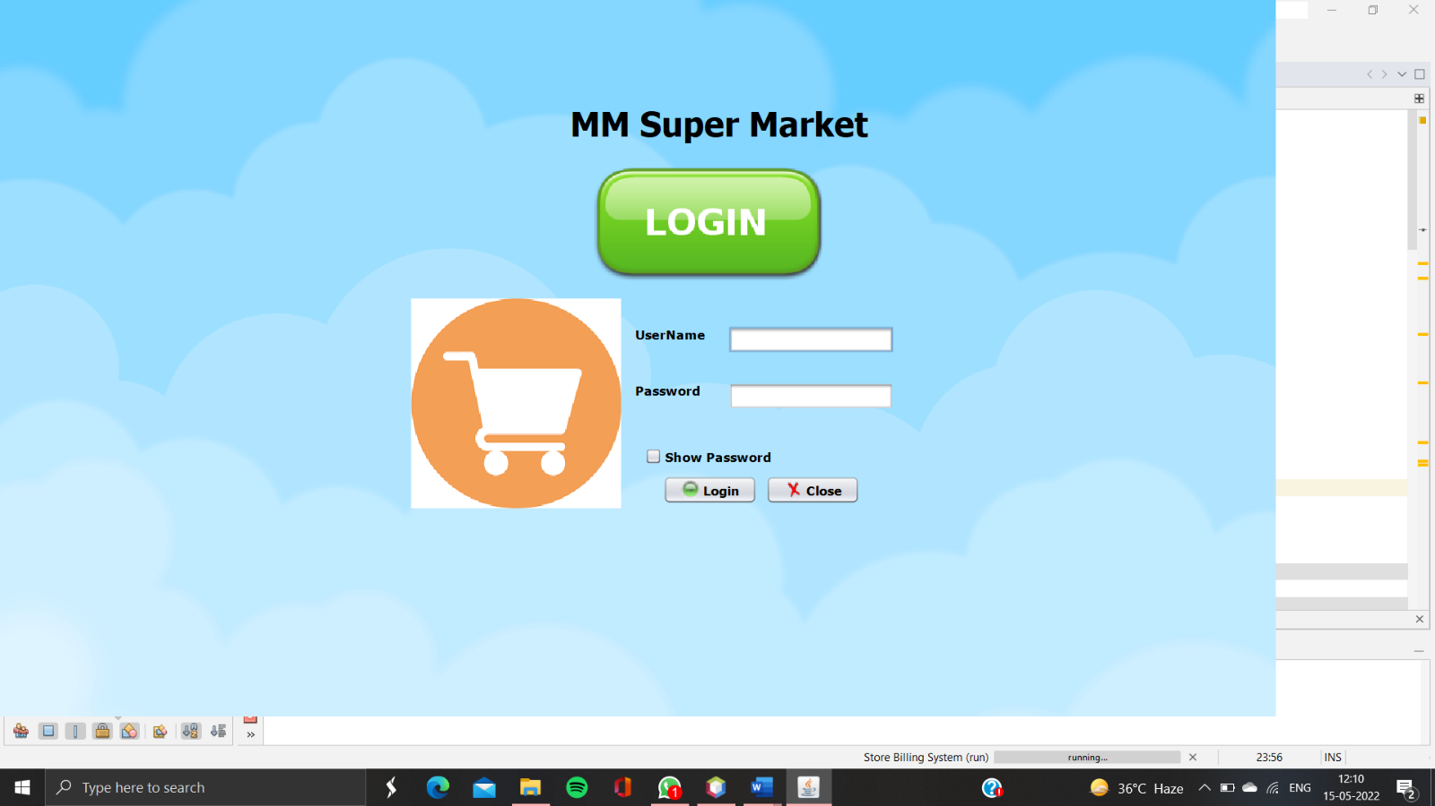

import javax.swing.JOptionPane;

public class login extends javax.swing.JFrame {

public login() {

initComponents();

}

@SuppressWarnings("unchecked")

// <editor-fold defaultstate="collapsed" desc="Generated Code">

private void jTextField1ActionPerformed(java.awt.event.ActionEvent evt) {

}

private void jCheckBox1ActionPerformed(java.awt.event.ActionEvent evt) {

if(jCheckBox1.isSelected())

{

jPasswordField1.setEchoChar((char)0);

}

else

{

jPasswordField1.setEchoChar('*');

}

}

private void jButton1ActionPerformed(java.awt.event.ActionEvent evt) {

if(jTextField1.getText().equals("CAM") && jPasswordField1.getText().equals("admin123"))

{

setVisible(false);

new home().setVisible(true);

}

else

JOptionPane.showMessageDialog(null,"Incorrect Username or Password");

}

private void jButton2ActionPerformed(java.awt.event.ActionEvent evt) {

int a=JOptionPane.showConfirmDialog(null,"Do you really want to close Application","Select",JOptionPane.YES_NO_OPTION);

if(a==0){

System.exit(0); }

}

public static void main(String args[]) {

java.awt.EventQueue.invokeLater(new Runnable() {

public void run() {

new login().setVisible(true);

}}); }

**6.2** **Home Page**

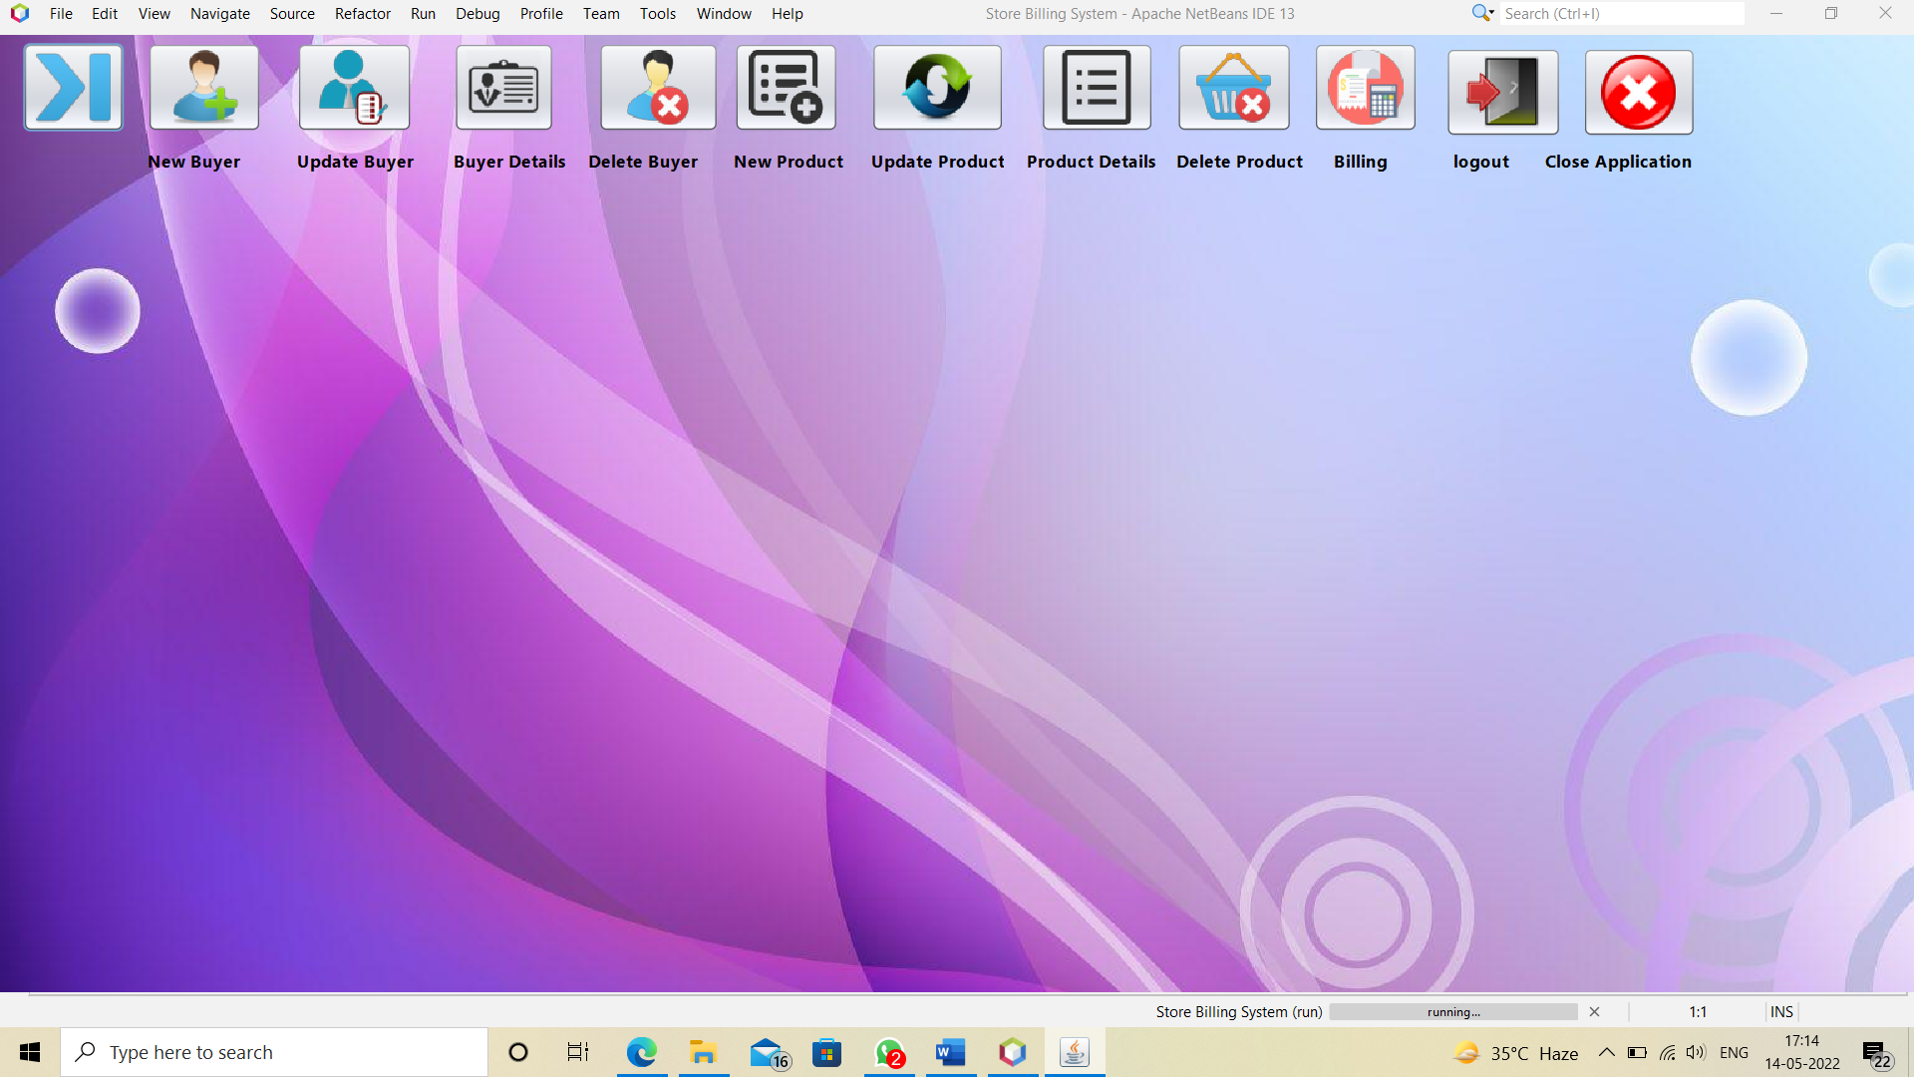

import javax.swing.JOptionPane;

public class home extends javax.swing.JFrame {

public int z=0; public home() {

initComponents();

jButton2.setVisible(false);

jButton3.setVisible(false);

jButton4.setVisible(false);

jButton5.setVisible(false);

jButton6.setVisible(false);

jButton7.setVisible(false);

jButton8.setVisible(false);

jButton9.setVisible(false);

jButton10.setVisible(false);

jButton11.setVisible(false);

jButton12.setVisible(false);

jLabel1.setVisible(false);

jLabel2.setVisible(false);

jLabel3.setVisible(false);

jLabel4.setVisible(false);

jLabel5.setVisible(false);

jLabel6.setVisible(false);

jLabel7.setVisible(false);

jLabel8.setVisible(false);

jLabel9.setVisible(false);

jLabel10.setVisible(false);

jLabel11.setVisible(false);

jLabel12.setVisible(false); }

@SuppressWarnings("unchecked")

// <editor-fold defaultstate="collapsed" desc="Generated Code">

private void jButton2ActionPerformed(java.awt.event.ActionEvent evt) {

new newBuyer().setVisible(true);

}

private void jButton3ActionPerformed(java.awt.event.ActionEvent evt) {

new updateBuyer().setVisible(true);

}

private void jButton8ActionPerformed(java.awt.event.ActionEvent evt) {

new productDetails().setVisible(true);

}

private void jButton10ActionPerformed(java.awt.event.ActionEvent evt) {

new billing().setVisible(true);

}

private void jButton11ActionPerformed(java.awt.event.ActionEvent evt) {

int a=JOptionPane.showConfirmDialog(null, "Do You Really want to Logout", "Select",JOptionPane.YES_NO_OPTION);

if(a==0){

setVisible(false);

new login().setVisible(true);

} }

private void jButton12ActionPerformed(java.awt.event.ActionEvent evt) {

int a=JOptionPane.showConfirmDialog(null, "Do You Really want to Close", "Select",JOptionPane.YES_NO_OPTION);

if(a==0)

{

System.exit(0);

} }

private void jButton1MouseClicked(java.awt.event.MouseEvent evt) {

if(z==0)

{ try{

Thread.sleep(250);

jButton2.setVisible(true);

jLabel1.setVisible(true);

}catch(Exception e)

{}

} else

{

jButton2.setVisible(false);

jButton3.setVisible(false);

jButton4.setVisible(false);

jButton5.setVisible(false);

jButton6.setVisible(false);

jButton7.setVisible(false);

jButton8.setVisible(false);

jButton9.setVisible(false);

jButton10.setVisible(false);

jButton11.setVisible(false);

jButton12.setVisible(false);

jLabel1.setVisible(false);

jLabel2.setVisible(false);

jLabel3.setVisible(false);

jLabel4.setVisible(false);

jLabel5.setVisible(false);

jLabel6.setVisible(false);

jLabel7.setVisible(false);

jLabel8.setVisible(false);

jLabel9.setVisible(false);

jLabel10.setVisible(false);

jLabel11.setVisible(false);

jLabel12.setVisible(false);

z=0; } }

private void jButton2ComponentShown(java.awt.event.ComponentEvent evt) {

try{

Thread.sleep(250);

jButton3.setVisible(true);

jLabel2.setVisible(true);

}catch(Exception e)

{}

}

private void jButton3ComponentShown(java.awt.event.ComponentEvent evt) {

try{

Thread.sleep(250);

jButton4.setVisible(true);

jLabel3.setVisible(true);

}catch(Exception e)

{} }

private void jButton4ComponentShown(java.awt.event.ComponentEvent evt) {

try{

Thread.sleep(250);

jButton5.setVisible(true);

jLabel4.setVisible(true);

}catch(Exception e)

{} }

private void jButton5ComponentShown(java.awt.event.ComponentEvent evt) {

try{

Thread.sleep(250);

jButton6.setVisible(true);

jLabel5.setVisible(true);

}catch(Exception e)

{} }

private void jButton6ComponentShown(java.awt.event.ComponentEvent evt) {

try{

Thread.sleep(250);

jButton7.setVisible(true);

jLabel6.setVisible(true);

}catch(Exception e)

{} }

private void jButton7ComponentShown(java.awt.event.ComponentEvent evt) {

try{

Thread.sleep(250);

jButton8.setVisible(true);

jLabel7.setVisible(true);

}catch(Exception e) {} }

private void jButton8ComponentShown(java.awt.event.ComponentEvent evt) {

try{

Thread.sleep(250);

jButton9.setVisible(true);

jLabel8.setVisible(true);

}catch(Exception e)

{} }

private void jButton9ComponentShown(java.awt.event.ComponentEvent evt) {

try{

Thread.sleep(250);

jButton10.setVisible(true);

jLabel10.setVisible(true);

}catch(Exception e)

{} }

private void jButton10ComponentShown(java.awt.event.ComponentEvent evt) {

try{

Thread.sleep(250);

jButton11.setVisible(true);

jLabel11.setVisible(true);

}catch(Exception e)

{} }

private void jButton11ComponentShown(java.awt.event.ComponentEvent evt) {

try{

Thread.sleep(250);

jButton12.setVisible(true);

jLabel12.setVisible(true);

z=1;

}catch(Exception e)

{} }

private void jButton4ActionPerformed(java.awt.event.ActionEvent evt) {

new buyersDetails().setVisible(true);

}

private void jButton5ActionPerformed(java.awt.event.ActionEvent evt) {

new deleteBuyer().setVisible(true);

}

private void jButton6ActionPerformed(java.awt.event.ActionEvent evt) {

new newProduct().setVisible(true);

}

private void jButton7ActionPerformed(java.awt.event.ActionEvent evt) {

new updateProduct().setVisible(true);

}

private void jButton9ActionPerformed(java.awt.event.ActionEvent evt) {

new deleteProduct().setVisible(true);

}

public static void main(String args[]) {

/* Create and display the form */

java.awt.EventQueue.invokeLater(new Runnable() {

public void run() {

new home().setVisible(true);

}

});

}

**6.3 J-Frames Forms And Codes**

New Buyer:

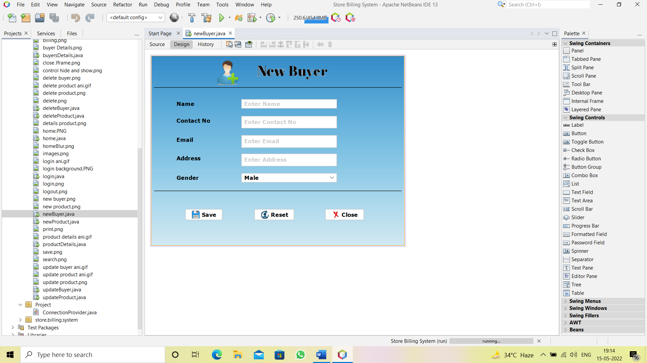

import java.awt.Color;

import Project.ConnectionProvider;

import java.sql.*;

import javax.swing.JOptionPane;

public class newBuyer extends javax.swing.JFrame {

public newBuyer() {

initComponents();

}

private void jTextField4ActionPerformed(java.awt.event.ActionEvent evt) {

// TODO add your handling code here:

}

private void jTextField1FocusGained(java.awt.event.FocusEvent evt) {

// TODO add your handling code here:

if(jTextField1.getText().equals("Enter Name"))

{

jTextField1.setText("");

jTextField1.setForeground(new Color(0,0,0));

} }

private void jTextField1FocusLost(java.awt.event.FocusEvent evt) {

// TODO add your handling code here:

if(jTextField1.getText().equals(""))

{

jTextField1.setText("Enter Name");

jTextField1.setForeground(new Color(153,153,153));

}

}

private void jTextField2FocusGained(java.awt.event.FocusEvent evt) {

// TODO add your handling code here:

if(jTextField2.getText().equals("Enter Contact No"))

{

jTextField2.setText("");

jTextField2.setForeground(new Color(0,0,0));

}

}

private void jTextField2FocusLost(java.awt.event.FocusEvent evt) {

// TODO add your handling code here:

if(jTextField2.getText().equals(""))

{

jTextField2.setText("Enter Contact No");

jTextField2.setForeground(new Color(153,153,153));

}

}

private void jTextField3FocusGained(java.awt.event.FocusEvent evt) {

// TODO add your handling code here:

if(jTextField3.getText().equals("Enter Email"))

{

jTextField3.setText("");

jTextField3.setForeground(new Color(0,0,0));

} }

private void jTextField3FocusLost(java.awt.event.FocusEvent evt) {

// TODO add your handling code here:

if(jTextField3.getText().equals(""))

{

jTextField3.setText("Enter Email");

jTextField3.setForeground(new Color(153,153,153));

} }

private void jTextField4FocusGained(java.awt.event.FocusEvent evt) {

if(jTextField4.getText().equals("Enter Address"))

{

jTextField4.setText("");

jTextField4.setForeground(new Color(0,0,0));

} }

private void jTextField4FocusLost(java.awt.event.FocusEvent evt) {

if(jTextField4.getText().equals(""))

{

jTextField4.setText("Enter Address");

jTextField4.setForeground(new Color(153,153,153));

} }

private void jButton3ActionPerformed(java.awt.event.ActionEvent evt) { setVisible(false);

} private void jButton2ActionPerformed(java.awt.event.ActionEvent evt) {

setVisible(false);

new newBuyer().setVisible(true);

}

private void jTextField1ActionPerformed(java.awt.event.ActionEvent evt) {

}

private void jButton1ActionPerformed(java.awt.event.ActionEvent evt) {

String name=jTextField1.getText();

String contactNo=jTextField2.getText();

String email=jTextField3.getText();

String address=jTextField4.getText();

String gender=(String)jComboBox1.getSelectedItem();

try{

Connection con=ConnectionProvider.getCon();

Statement st=con.createStatement();

st.executeUpdate("insert into buyer values('"+name+"','"+contactNo+"','"+email+"','"+address+"','"+gender+"')");

JOptionPane.showMessageDialog(null,"Successfully Updated");

setVisible(false);

new newBuyer().setVisible(true);

}

catch(Exception e)

{

JOptionPane.showMessageDialog(null,"Mobile Number is already Exist");

} }

public static void main(String args[]) {

java.awt.EventQueue.invokeLater(new Runnable() {

public void run() {

new newBuyer().setVisible(true);

}

});

}

 Update Buyer:

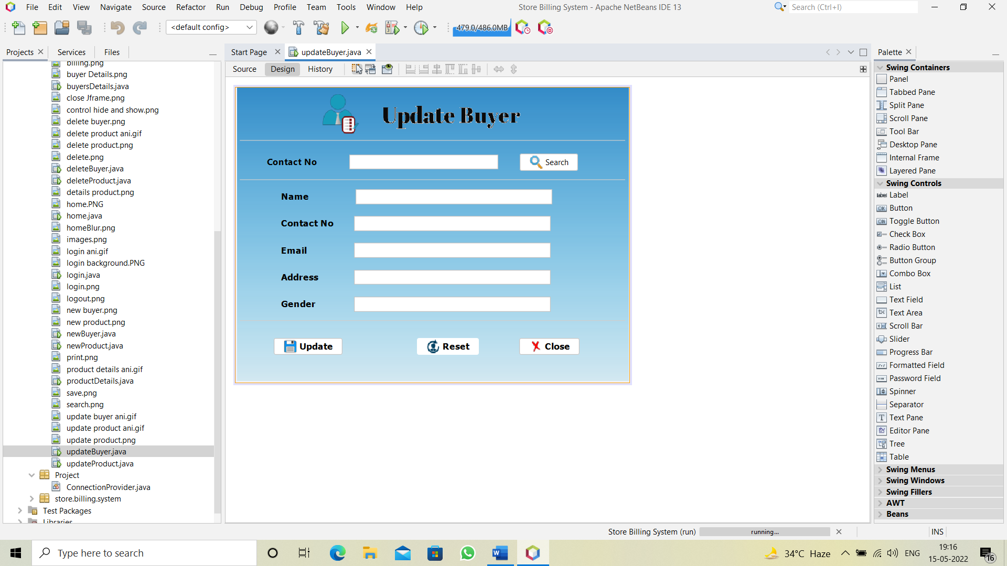

import java.sql.*;

import Project.ConnectionProvider;

import javax.swing.JOptionPane;

public class updateBuyer extends javax.swing.JFrame {

public updateBuyer() {

initComponents();

}

private void jButton1ActionPerformed(java.awt.event.ActionEvent evt) {

// TODO add your handling code here:

String contactNo=jTextField1.getText();

try

{

Connection con =ConnectionProvider.getCon();

Statement st= con.createStatement();

ResultSet rs=st.executeQuery("select *from buyer where contactNO='"+contactNo+"'");

if(rs.next())

{ jTextField2.setText(rs.getString(1));

jTextField3.setText(rs.getString(2));

jTextField4.setText(rs.getString(3));

jTextField5.setText(rs.getString(4));

jTextField6.setText(rs.getString(5));

jTextField1.setEditable(false);

}

else

JOptionPane.showMessageDialog(null,"ContactNo does Not exist");

}

catch(Exception e)

{

JOptionPane.showMessageDialog(null, e);

}

}

private void jTextField2ActionPerformed(java.awt.event.ActionEvent evt) {

}

private void jTextField4ActionPerformed(java.awt.event.ActionEvent evt) {

}

private void jButton3ActionPerformed(java.awt.event.ActionEvent evt) {

setVisible(false);

new updateBuyer().setVisible(true);

}

private void jButton4ActionPerformed(java.awt.event.ActionEvent evt) {

setVisible(false);

}

private void jButton2ActionPerformed(java.awt.event.ActionEvent evt) {

String contactNo1=jTextField1.getText();

String name=jTextField2.getText();

String contactNo=jTextField3.getText();

String email=jTextField4.getText();

String address=jTextField5.getText();

String gender=jTextField6.getText();

try

{

Connection con=ConnectionProvider.getCon();

Statement st=con.createStatement();

st.executeUpdate("update buyer set name='"+name+"',contactNo='"+contactNo+"',email='"+email+"',address='"+address+"',gender='"+gender+"' where contactNo='"+contactNo1+"'");

JOptionPane.showMessageDialog(null,"Successfully Updated");

setVisible(false);

new updateBuyer().setVisible(true);

}

catch(Exception e)

{

JOptionPane.showMessageDialog(null,e);

}

}

public static void main(String args[]) {

java.awt.EventQueue.invokeLater(new Runnable() {

public void run() {

new updateBuyer().setVisible(true);

}

});

}

 Buyer Details:

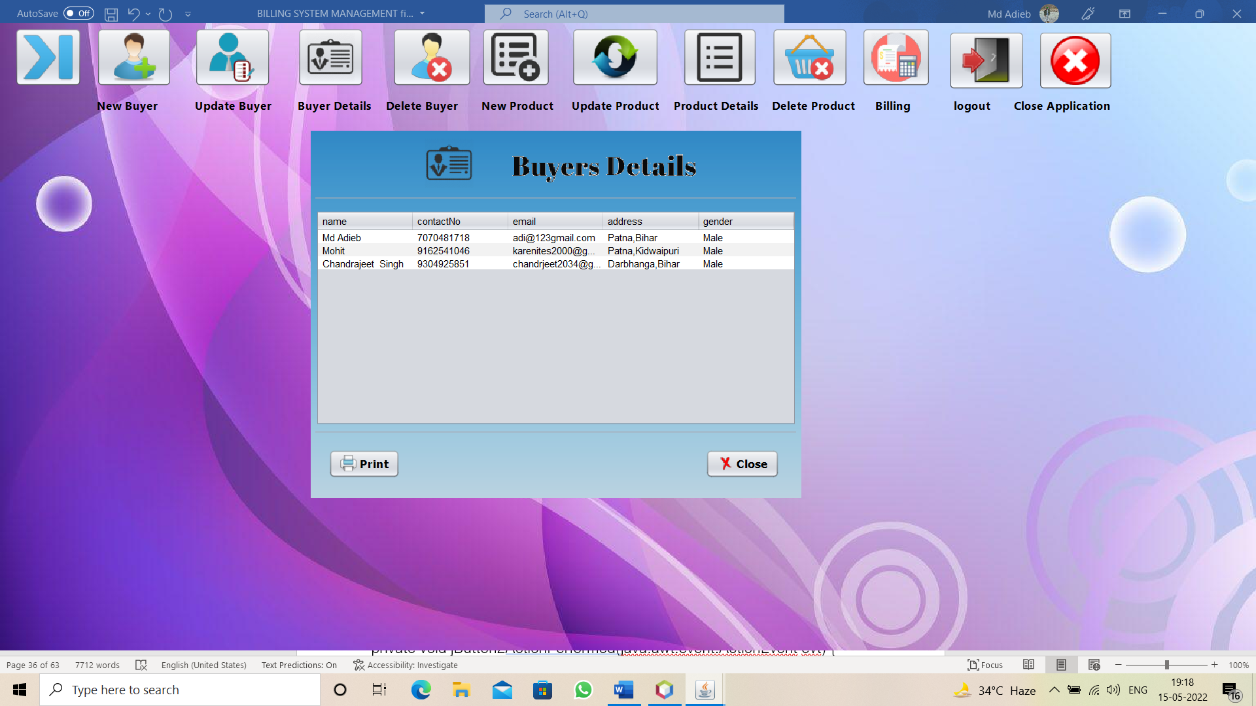

import javax.swing.JTable;

import java.sql.*;

import Project.ConnectionProvider;

import javax.swing.JOptionPane;

import net.proteanit.sql.DbUtils;

public class buyersDetails extends javax.swing.JFrame {

public buyersDetails() {

initComponents();

}

private void jButton2ActionPerformed(java.awt.event.ActionEvent evt) {

setVisible(false);

}

private void jButton1ActionPerformed(java.awt.event.ActionEvent evt) {

try

{

jTable1.print(JTable.PrintMode.NORMAL);

}

catch(Exception e)

{}

}

private void formComponentShown(java.awt.event.ComponentEvent evt) {

try

{

Connection con=ConnectionProvider.getCon();

Statement st=con.createStatement();

ResultSet rs=st.executeQuery("select *from buyer");

jTable1.setModel(DbUtils.resultSetToTableModel(rs));

}

catch(Exception e)

{

JOptionPane.showMessageDialog(null, e);

}

}

public static void main(String args[]) {

/* Create and display the form */

java.awt.EventQueue.invokeLater(new Runnable() {

public void run() {

new buyersDetails().setVisible(true);

} }); }

 Delete Buyer:

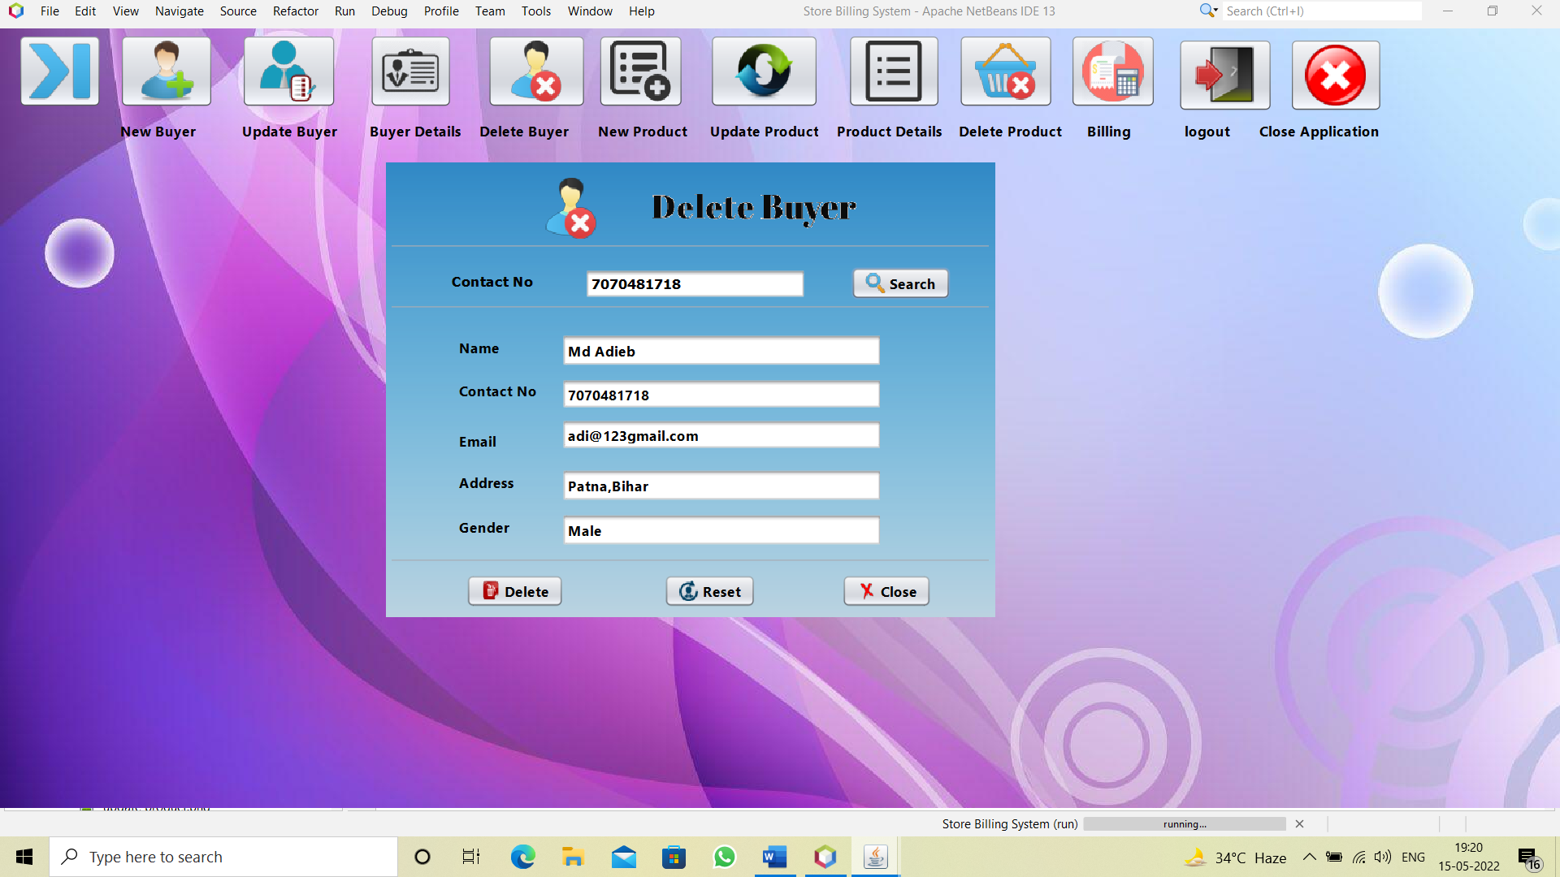

import java.sql.*;

import Project.ConnectionProvider;

import javax.swing.JOptionPane;

public class deleteBuyer extends javax.swing.JFrame {

public deleteBuyer() {

initComponents();

}

private void jTextField3ActionPerformed(java.awt.event.ActionEvent evt) {

// TODO add your handling code here:

}

private void jTextField5ActionPerformed(java.awt.event.ActionEvent evt) {

// TODO add your handling code here:

}

private void jButton4ActionPerformed(java.awt.event.ActionEvent evt) {

// TODO add your handling code here:

setVisible(false);

}

private void jButton3ActionPerformed(java.awt.event.ActionEvent evt) {

// TODO add your handling code here:

setVisible(false);

new deleteBuyer().setVisible(true);

}

private void jButton1ActionPerformed(java.awt.event.ActionEvent evt) {

// TODO add your handling code here:

String contactNo=jTextField1.getText();

try

{

Connection con=ConnectionProvider.getCon();

Statement st=con.createStatement();

ResultSet rs=st.executeQuery("select *from buyer where contactNo='"+contactNo+"'");

if(rs.next()){

jTextField2.setText(rs.getString(1));

jTextField3.setText(rs.getString(2));

jTextField4.setText(rs.getString(3));

jTextField5.setText(rs.getString(4));

jTextField6.setText(rs.getString(5));

jTextField1.setEditable(false);

}

else

JOptionPane.showMessageDialog(null,"Contact No does not exist");

}

catch(Exception e)

{

JOptionPane.showMessageDialog(null, e);

}

}

private void jButton2ActionPerformed(java.awt.event.ActionEvent evt) {

// TODO add your handling code here:

String contactNo=jTextField1.getText();

int a=JOptionPane.showConfirmDialog(null,"Do you really want to delete","Select",JOptionPane.YES_NO_OPTION);

if(a==0)

{

try

{

Connection con=ConnectionProvider.getCon();

Statement st=con.createStatement();

st.executeUpdate("delete from buyer where contactNo='"+contactNo+"'");

setVisible(false);

new deleteBuyer().setVisible(true);

}

catch(Exception e)

{}

}

}

public static void main(String args[]) {

/* Create and display the form */

java.awt.EventQueue.invokeLater(new Runnable() {

public void run() {

new deleteBuyer().setVisible(true);

}

});

}

 New Product:

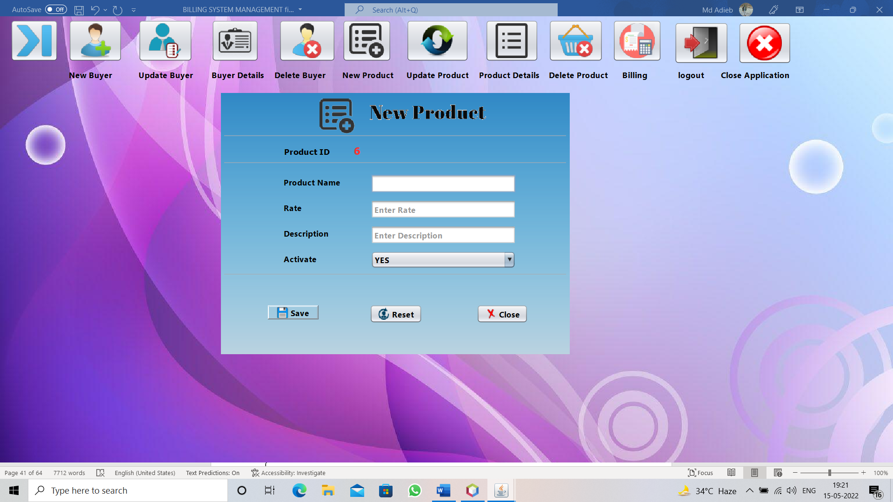

import java.sql.*;

import Project.ConnectionProvider;

import java.awt.Color;

import javax.swing.JOptionPane;

public class newProduct extends javax.swing.JFrame {

public newProduct() {

initComponents();

}

private void formComponentShown(java.awt.event.ComponentEvent evt) {

// TODO add your handling code here:

try

{

Connection con=ConnectionProvider.getCon();

Statement st=con.createStatement(ResultSet.TYPE_SCROLL_SENSITIVE, ResultSet.CONCUR_READ_ONLY);

ResultSet rs=st.executeQuery("select max(pId) from product");

if(rs.first())

{

int id=rs.getInt(1);

id = id+1;

String str=String.valueOf(id);

jLabel4.setText(str);

}

else

jLabel4.setText("1");

}

catch(Exception e)

{

JOptionPane.showMessageDialog(null,e);

}

}

private void jTextField1FocusGained(java.awt.event.FocusEvent evt) {

// TODO add your handling code here:

if(jTextField1.getText().equals("Enter Product Name"))

{

jTextField1.setText("");

jTextField1.setForeground(new Color(0,0,0));

}

}

private void jTextField1FocusLost(java.awt.event.FocusEvent evt) {

// TODO add your handling code here:

if(jTextField1.getText().equals(""))

{

jTextField1.setText("Enter Product Name");

jTextField1.setForeground(new Color(153,153,153));

}

}

private void jTextField2FocusGained(java.awt.event.FocusEvent evt) {

// TODO add your handling code here:

if(jTextField2.getText().equals("Enter Rate"))

{

jTextField2.setText("");

jTextField2.setForeground(new Color(0,0,0));

} }

private void jTextField2HierarchyChanged(java.awt.event.HierarchyEvent evt) {

// TODO add your handling code here:

}

private void jTextField2FocusLost(java.awt.event.FocusEvent evt) {

// TODO add your handling code here:

if(jTextField2.getText().equals(""))

{

jTextField2.setText("Enter Rate");

jTextField2.setForeground(new Color(153,153,153));

}

}

private void jTextField3FocusGained(java.awt.event.FocusEvent evt) {

// TODO add your handling code here:

if(jTextField3.getText().equals("Enter Description"))

{

jTextField3.setText("");

jTextField3.setForeground(new Color(0,0,0));

}

}

private void jTextField3FocusLost(java.awt.event.FocusEvent evt) {

// TODO add your handling code here:

if(jTextField3.getText().equals(""))

{

jTextField3.setText("Enter Description");

jTextField3.setForeground(new Color(153,153,153));

}

}

private void jButton1ActionPerformed(java.awt.event.ActionEvent evt) {

// TODO add your handling code here:

String pId=jLabel4.getText();

String pName=jTextField1.getText();

String rate=jTextField2.getText();

String description=jTextField3.getText();

String activate=(String)jComboBox1.getSelectedItem();

try

{

Connection con=ConnectionProvider.getCon();

Statement st=con.createStatement();

st.executeUpdate("insert into product values('"+pId+"','"+pName+"','"+rate+"','"+description+"','"+activate+"')");

JOptionPane.showMessageDialog(null, "Successfully Updated");

setVisible(false);

new newProduct().setVisible(true);

}

catch(Exception e)

{

JOptionPane.showMessageDialog(null, e);

}

}

private void jButton3ActionPerformed(java.awt.event.ActionEvent evt) {

// TODO add your handling code here:

setVisible(false);

}

private void jButton2ActionPerformed(java.awt.event.ActionEvent evt) {

// TODO add your handling code here:

setVisible(false);

new newProduct().setVisible(true);

}

private void jTextField1ActionPerformed(java.awt.event.ActionEvent evt) {

// TODO add your handling code here:

}

public static void main(String args[]) {

/* Create and display the form */

java.awt.EventQueue.invokeLater(new Runnable() {

public void run() {

new newProduct().setVisible(true);}}}

 Update Product:

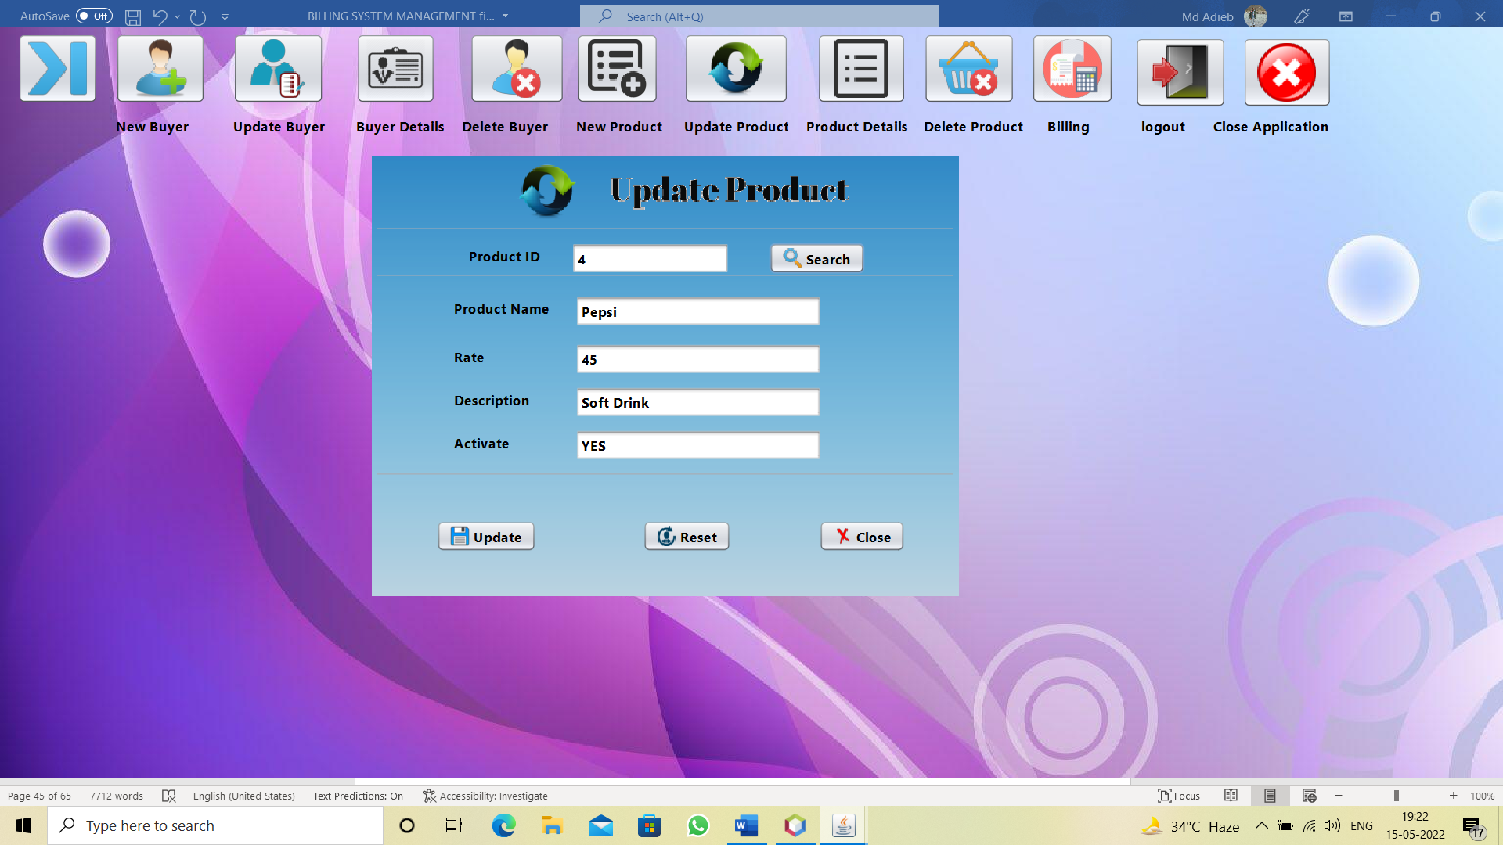

import java.sql.*;

import Project.ConnectionProvider;

import javax.swing.JOptionPane;

public class updateProduct extends javax.swing.JFrame {

public updateProduct() {

initComponents();

}

private void jButton4ActionPerformed(java.awt.event.ActionEvent evt) {

// TODO add your handling code here:

setVisible(false);

}

private void jButton3ActionPerformed(java.awt.event.ActionEvent evt) {

// TODO add your handling code here:

setVisible(false);

new updateProduct().setVisible(true);

}

private void jButton1ActionPerformed(java.awt.event.ActionEvent evt) {

// TODO add your handling code here:

String pId=jTextField1.getText();

try

{

Connection con=ConnectionProvider.getCon();

Statement st=con.createStatement();

ResultSet rs=st.executeQuery("select *from product where pId='"+pId+"'");

if(rs.next())

{

jTextField2.setText(rs.getString(2));

jTextField3.setText(rs.getString(3));

jTextField4.setText(rs.getString(4));

jTextField5.setText(rs.getString(5));

jTextField1.setEditable(false);

}

else

JOptionPane.showMessageDialog(null,"Product id does not exist");

}

catch(Exception e)

{

JOptionPane.showMessageDialog(null,e);

}

}

private void jButton2ActionPerformed(java.awt.event.ActionEvent evt) {

// TODO add your handling code here:

String pId=jTextField1.getText();

String pName=jTextField2.getText();

String rate=jTextField3.getText();

String description=jTextField4.getText();

String activate=jTextField5.getText();

try

{

Connection con=ConnectionProvider.getCon();

Statement st=con.createStatement();

st.executeUpdate("update product set pName='"+pName+"',rate='"+rate+"',description='"+description+"',activate='"+activate+"' where pId='"+pId+"'");

JOptionPane.showMessageDialog(null,"Successfully Updated");

setVisible(false);

new updateProduct().setVisible(true);

}

catch(Exception e)

{

JOptionPane.showMessageDialog(null, e);

}

}

public static void main(String args[]) {

/* Create and display the form */

java.awt.EventQueue.invokeLater(new Runnable() {

public void run() {

new updateProduct().setVisible(true);

}

});

}

Product Details:



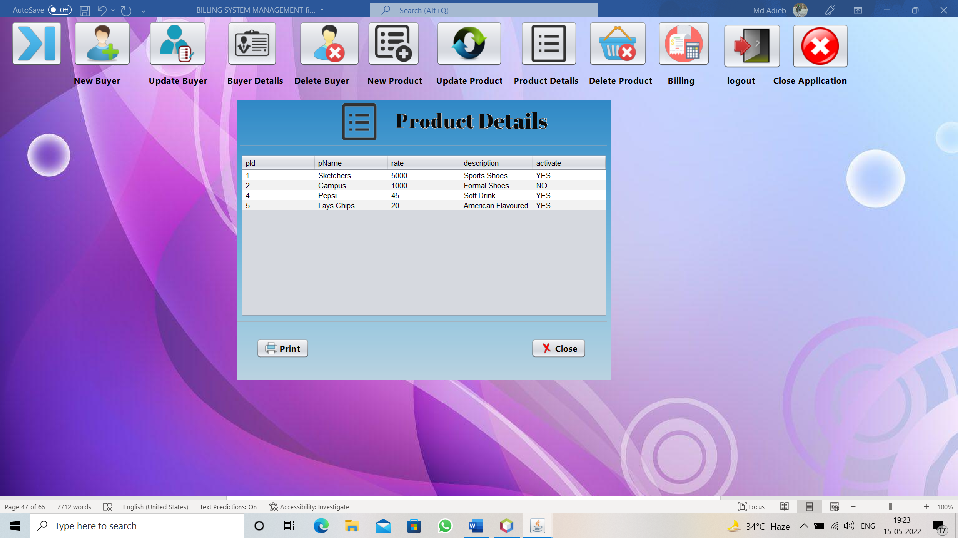

import Project.ConnectionProvider;

import java.sql.*;

import javax.swing.JOptionPane;

import javax.swing.JTable;

import net.proteanit.sql.DbUtils;

public class productDetails extends javax.swing.JFrame {

public productDetails() {

initComponents();

}

private void formComponentShown(java.awt.event.ComponentEvent evt) {

// TODO add your handling code here:

try

{

Connection con=ConnectionProvider.getCon();

Statement st=con.createStatement();

ResultSet rs=st.executeQuery("select *from product");

jTable1.setModel(DbUtils.resultSetToTableModel(rs));

}

catch(Exception e)

{

JOptionPane.showMessageDialog(null,e);

}

}

private void jButton2ActionPerformed(java.awt.event.ActionEvent evt) {

// TODO add your handling code here:

setVisible(false);

}

private void jButton1ActionPerformed(java.awt.event.ActionEvent evt) {

// TODO add your handling code here:

try

{

jTable1.print(JTable.PrintMode.NORMAL);

}

catch(Exception e)

{

JOptionPane.showMessageDialog(null, e);

} }

public static void main(String args[]) {

java.awt.EventQueue.invokeLater(new Runnable() {

public void run() {

new productDetails().setVisible(true);

}

});

}

 Delete Product:

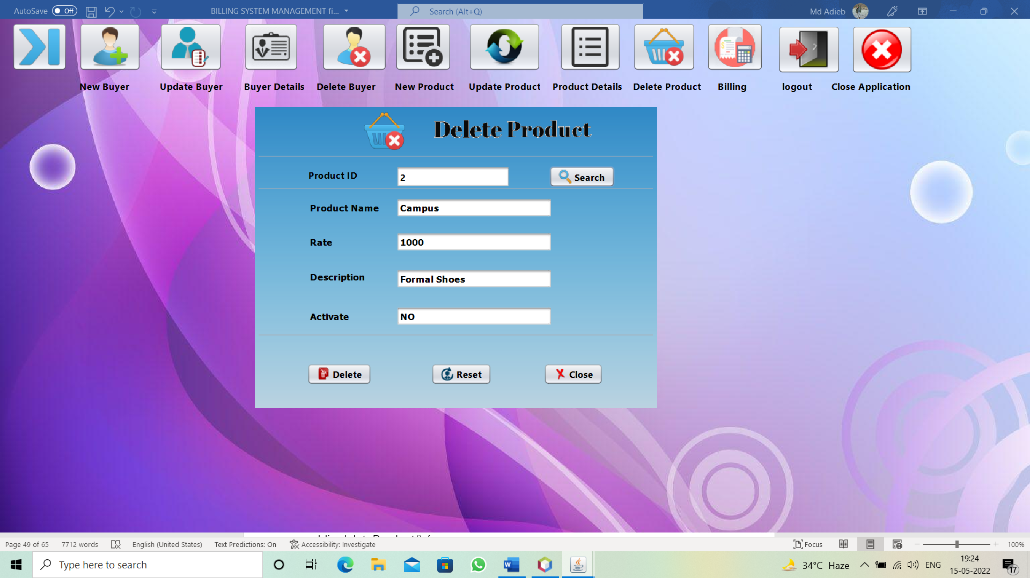

import java.sql.*;

import Project.ConnectionProvider;

import javax.swing.JOptionPane;

public class deleteProduct extends javax.swing.JFrame {

public deleteProduct() {

initComponents();

}

private void jButton3ActionPerformed(java.awt.event.ActionEvent evt) {

// TODO add your handling code here:

setVisible(false);

new deleteProduct().setVisible(true);

}

private void jButton4ActionPerformed(java.awt.event.ActionEvent evt) {

// TODO add your handling code here:

setVisible(false);

}

private void jButton1ActionPerformed(java.awt.event.ActionEvent evt) {

// TODO add your handling code here:

String pId=jTextField1.getText();

try

{

Connection con=ConnectionProvider.getCon();

Statement st=con.createStatement();

ResultSet rs=st.executeQuery("select *from product where pId='"+pId+"'");

if(rs.next())

{

jTextField2.setText(rs.getString(2));

jTextField3.setText(rs.getString(3));

jTextField4.setText(rs.getString(4));

jTextField5.setText(rs.getString(5));

jTextField1.setEditable(false);

}

else

JOptionPane.showMessageDialog(null,"ProductId does not exist");

}

catch(Exception e)

{}

}

private void jButton2ActionPerformed(java.awt.event.ActionEvent evt) {

// TODO add your handling code here:

String pId=jTextField1.getText();

int a=JOptionPane.showConfirmDialog(null, "Do you want to Delete","Select",JOptionPane.YES_NO_OPTION);

if(a==0)

{

try

{

Connection con=ConnectionProvider.getCon();

Statement st=con.createStatement();

st.executeUpdate("delete from product where pId='"+pId+"'");

setVisible(false);

new deleteProduct().setVisible(true);

}

catch(Exception e)

{

JOptionPane.showMessageDialog(null, e);

} } }

public static void main(String args[]) {

/* Create and display the form */

java.awt.EventQueue.invokeLater(new Runnable() {

public void run() {

new deleteProduct().setVisible(true);

}

});

}

 Billing :

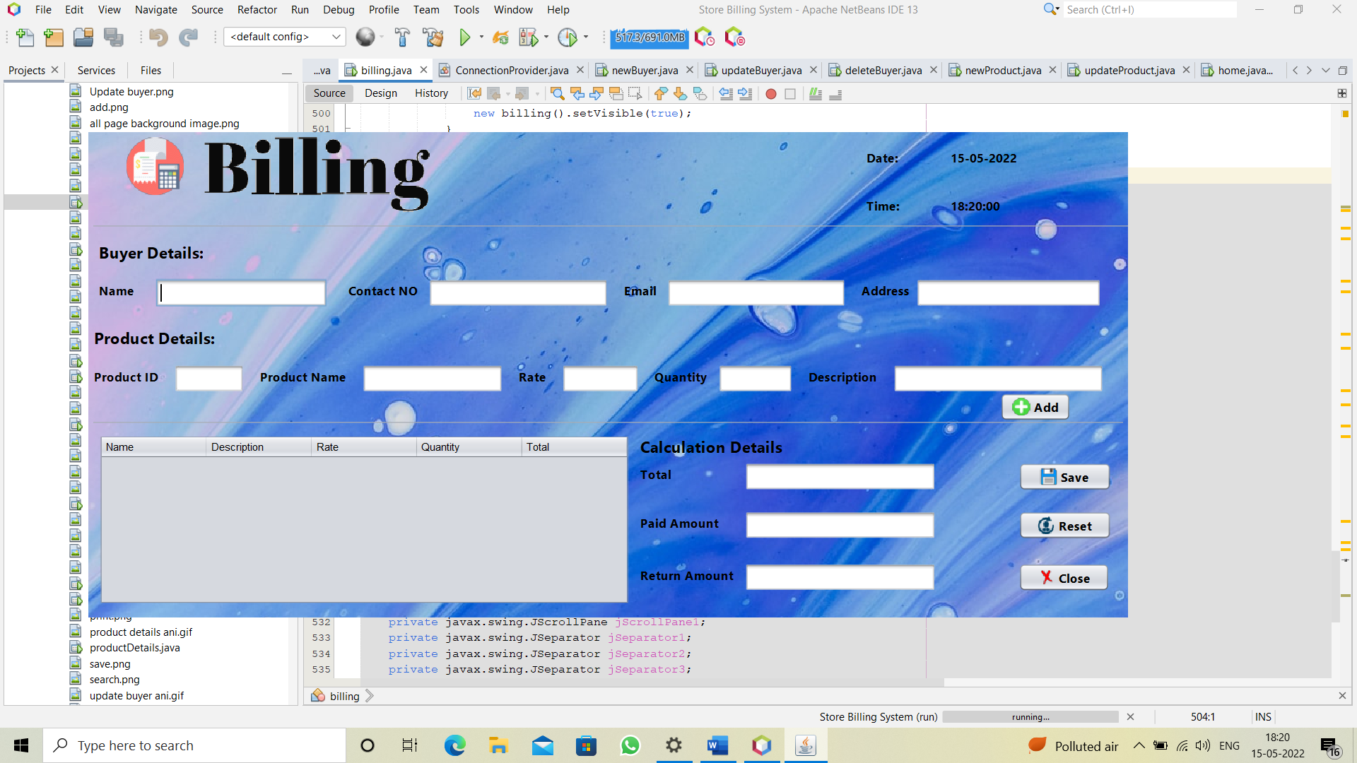

import java.sql.*;

import Project.ConnectionProvider;

import com.itextpdf.text.Paragraph;

import com.itextpdf.text.pdf.PdfPTable;

import com.itextpdf.text.pdf.PdfWriter;

import java.io.FileOutputStream;

import java.text.SimpleDateFormat;

import java.time.LocalDateTime;

import java.time.format.DateTimeFormatter;

import javax.swing.JOptionPane;

import java.util.Date;

import javax.swing.table.DefaultTableModel;

public class billing extends javax.swing.JFrame {

public int finalTotal=0;

public billing() {

initComponents();

SimpleDateFormat dFormat=new SimpleDateFormat("dd-MM-yyyy");

Date date=new Date();

jLabel5.setText(dFormat.format(date));

DateTimeFormatter dtf=DateTimeFormatter.ofPattern("HH:mm:ss");

LocalDateTime now=LocalDateTime.now();

jLabel6.setText(dtf.format(now));

}

private void jTextField11ActionPerformed(java.awt.event.ActionEvent evt) {

// TODO add your handling code here:

String paidAmount=jTextField11.getText();

int z=Integer.parseInt(paidAmount);

finalTotal=z-finalTotal;

String finalTotal1=String.valueOf(finalTotal);

jTextField12.setText(finalTotal1);

jTextField12.setEditable(false);

}

private void jButton4ActionPerformed(java.awt.event.ActionEvent evt) {

// TODO add your handling code here:

setVisible(false);

}

private void jTextField1ActionPerformed(java.awt.event.ActionEvent evt) {

// TODO add your handling code here:

String name=jTextField1.getText();

try

{

Connection con=ConnectionProvider.getCon();

Statement st=con.createStatement();

ResultSet rs=st.executeQuery("select *from buyer where name like '"+name+"%'");

if(rs.next())

{

jTextField1.setText(rs.getString(1));

jTextField2.setText(rs.getString(2));

jTextField3.setText(rs.getString(3));

jTextField4.setText(rs.getString(4));

}

else

{

jTextField2.setText("");

jTextField3.setText("");

jTextField4.setText("");

} }

catch(Exception e)

{

JOptionPane.showMessageDialog(null,e);

}}

private void jTextField2ActionPerformed(java.awt.event.ActionEvent evt) {

// TODO add your handling code here:

String contactNo=jTextField2.getText();

try

{

Connection con=ConnectionProvider.getCon();

Statement st=con.createStatement();

ResultSet rs=st.executeQuery("select *from buyer where contactNo like '"+contactNo+"%'");

if(rs.next())

{

jTextField1.setText(rs.getString(1));

jTextField2.setText(rs.getString(2));

jTextField3.setText(rs.getString(3));

jTextField4.setText(rs.getString(4));

}

else

{

jTextField1.setText("");

jTextField3.setText("");

jTextField4.setText("");

}

}

catch(Exception e)

{

JOptionPane.showMessageDialog(null,e);

}

}

private void jTextField5ActionPerformed(java.awt.event.ActionEvent evt) {

// TODO add your handling code here:

String pId=jTextField5.getText();

try

{

Connection con=ConnectionProvider.getCon();

Statement st=con.createStatement();

ResultSet rs=st.executeQuery("select *from product where pId like '"+pId+"%'");

if(rs.next())

{

jTextField6.setText(rs.getString(2));

jTextField7.setText(rs.getString(3));

jTextField8.setText("1");

jTextField9.setText(rs.getString(4));

}

else

{

jTextField6.setText("");

jTextField7.setText("");

jTextField8.setText("");

jTextField9.setText("");

}

}

catch(Exception e)

{

JOptionPane.showMessageDialog(null,e);

}

}

private void jButton1ActionPerformed(java.awt.event.ActionEvent evt) {

// TODO add your handling code here:

int price=Integer.parseInt(jTextField7.getText());

int quantity=Integer.parseInt(jTextField8.getText());

int total=price*quantity;

DefaultTableModel model=(DefaultTableModel)jTable1.getModel();

model.addRow(newObject[]{jTextField6.getText(),jTextField9.getText(),

price,quantity,total});

finalTotal=finalTotal+total;

String finalTotal1=String.valueOf(finalTotal);

jTextField10.setText(finalTotal1);

}

private void jButton3ActionPerformed(java.awt.event.ActionEvent evt) {

// TODO add your handling code here:

setVisible(false);

new billing().setVisible(true);

}

private void jButton2ActionPerformed(java.awt.event.ActionEvent evt) {

// TODO add your handling code here:

String name=jTextField1.getText();

String contactNo=jTextField2.getText();

String email=jTextField3.getText();

String address=jTextField4.getText();

String path="E:\\Bills\\";

com.itextpdf.text.Document doc=new com.itextpdf.text.Document();

try

{

PdfWriter.getInstance(doc,new FileOutputStream

( path+""+name+""+jLabel5.getText()+".pdf"));

doc.open();

Paragraph paragraph1=new Paragraph(" CAM tech(Billing

Mangement System)\n Contact Number:(+91)7070481718\n\n");

doc.add(paragraph1);

Paragraph paragraph2=new Paragraph("Date & Time:"+jLabel5.getText()+

" "+jLabel6.getText()+"\nBuyer Details:\nName:"+name+"\nContact

No:"+contactNo+"\nEmail:"+email+"\nAddress:"+address+"\n\n");

doc.add(paragraph2);

PdfPTable tb1=new PdfPTable(5);

tb1.addCell("Name");

tb1.addCell("Description");

tb1.addCell("Rate");

tb1.addCell("Quantity");

tb1.addCell("Sub Total");

for(int i=0;i<jTable1.getRowCount();i++)

{

String n=jTable1.getValueAt(i,0).toString();

String d=jTable1.getValueAt(i,1).toString();

String r=jTable1.getValueAt(i,2).toString();

String q=jTable1.getValueAt(i,3).toString();

String s=jTable1.getValueAt(i,4).toString();

tb1.addCell(n);

tb1.addCell(d);

tb1.addCell(r);

tb1.addCell(q);

tb1.addCell(s); }

doc.add(tb1);

Paragraph paragraph3=new Paragraph("\nTotal :"+jTextField10.getText()+"\nPaid Amount :"+jTextField11.getText()+"\nReturn Amount :"+jTextField12.getText()+"\n\nThank you for visiting !Please Come again. \nCAM tech");

doc.add(paragraph3);

JOptionPane.showMessageDialog(null,"Bill Generated");

setVisible(true);

new billing().setVisible(true);

}

catch(Exception e)

{

JOptionPane.showMessageDialog(null, e);

}

doc.close(); }

public static void main(String args[]) {

java.awt.EventQueue.invokeLater(new Runnable() {

public void run() {

new billing().setVisible(true);} }); }

**6.4 SQL Database:**

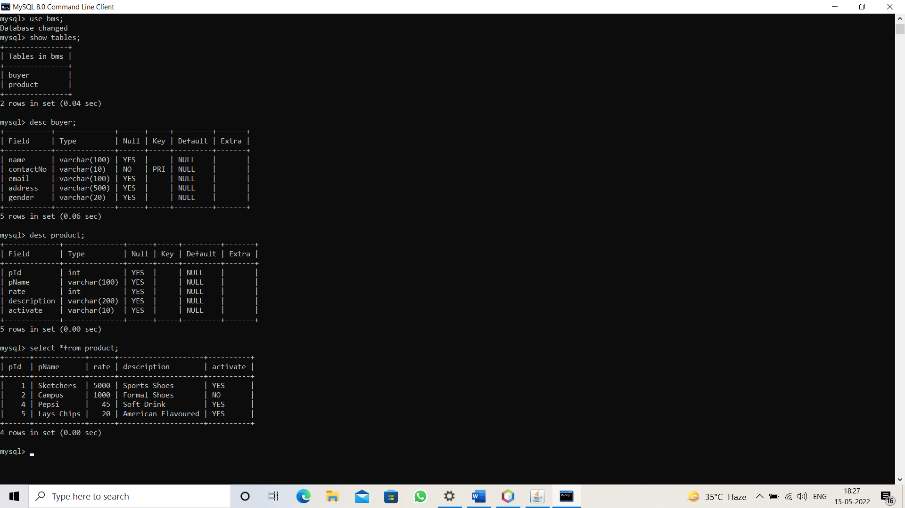

***CONNECTION PROVIDER WITH MySql:-***

package Project;

import java.sql.*;

public class ConnectionProvider {

public static Connection getCon()

{

try

{

Class.forName("com.mysql.jdbc.Driver");

Connection con=DriverManager.getConnection("jdbc:mysql://localhost:3306/bms","root","***********");

return con;

**7.0 TESTING**

**Software Testing**

. Test techniques include, but are not limited to, the process of executing a program or application with the intent of finding software bugs. Software Testing can also be stated as the process of validating and verifying that a softwareprogram/ application/ product  meets the business and technical requirements that guided its design and development;

·         works as expected; and

·         can be implemented with the same characteristics.

Software Testing, depending on the testing method employed, can be implemented at any time in the development process, however most of the test effort occurs after the requirements have been defined and the coding process has been completed

**7.1 TESTING METHODS**

Software testing methods are traditionally divided into black box testing and white box testing. These two approaches are used to describe the point of view that a test engineer takes when designing test cases.

**Black box testing**

Black box testing treats the software as a "black box"—without any knowledge of internal implementation. Black box testing methods include: equivalence partitioning, boundary value analysis, all-pairs testing, fuzz testing, model-based testing, traceability matrix, exploratory testing and specification-based testing.

**Specification-based testing**: Specification-based testing aims to test the functionality of software according to the applicable requirements. Thus, the tester inputs data into, and only sees the output from, the test object. This level of testing usually requires thorough test cases to be provided to the tester, who then can simply verify that for a given input, the output value (or behavior), either "is" or "is not" the same as the expected value specified in the test case.

Specification-based testing is necessary, but it is insufficient to guard against certain risks.

**Advantages and disadvantages**: The black box tester has no "bonds" with the code, and a tester's perception is very simple: a code *must* have bugs. Using the principle, "Ask and you shall receive," black box testers find bugs where programmers do not. *But,* on the other hand, black box testing has been said to be "like a walk in a dark labyrinth without a flashlight," because the tester doesn't know how the software being tested was actually constructed.

As a result, there are situations when (1) a tester writes many test cases to check something that could have been tested by only one test case, and/or (2) some parts of the back-end are not tested at all.

Therefore, black box testing has the advantage of "an unaffiliated opinion," on the one hand, and the disadvantage of "blind exploring," on the other.

**White box testing**

White box testing is when the tester has access to the internal data structures and algorithms including the code that implement these.

Types of white box testing

·    API testing (application programming interface) - Testing of the application using Public and Private APIs

·   Code coverage - creating tests to satisfy some criteria of code coverage (e.g., the test designer can create tests to cause all statements in the program to be executed at least once)

·  Fault injection methods - improving the coverage of a test by introducing faults to test code paths

·               Mutation testing methods

·               Static testing - White box testing includes all static testing

**A sample testing cycle**

Although variations exist between organizations, there is a typical cycle for testing:

· **Requirements analysis**: Testing should begin in the requirements phase of the software development life cycle. During the design

phase, testers work with developers in determining what aspects of a design are testable and with what parameters those tests work.

·**Test planning**: Test strategy, test plan, tested creation. Since many activities will be carried out during testing, a plan is needed.

·**Test development**: Test procedures, test scenarios, test cases, test datasets, test scripts to use in testing software

·**Test execution**: Testers execute the software based on the plans and tests and report any errors found to the development team.

·**Test reporting**: Once testing is completed, testers generate metrics and make final reports on their test effort and whether or not the software tested is ready for release.

·**Test result analysis**: Or Defect Analysis, is done by the development team usually along with the client, in order to decide what defects should be treated, fixed, rejected (i.e. found software working properly) or deferred to be dealt with later.

·**Defect Retesting**: Once a defect has been dealt with by the development team, it is retested by the testing team.

· **Regression testing**: It is common to have a small test program built of a subset of tests, for each integration of new, modified, or fixed software, in order to ensure that the latest delivery has not ruined anything, and that the software product as a whole is still working correctly.

· **Test Closure**: Once the test meets the exit criteria, the activities such as capturing the key outputs, lessons learned, results, logs,

documents related to the project are archived and used as a reference for future projects.

**7.2 Test Approach:**

Testing can be done in two ways:

Bottom-up approach

Top-down approach

**1 Bottom up Approach:**

Testing can be performed starting from smallest and lowest level modules and proceeding one at a time. For each module in bottom up testing a short program executes the module and provides the needed data so that the module is asked to perform the way it will when embedded with in the larger system. When bottom level

modules are tested attention turns to those on the next level that use the lower level ones they are tested individually and then linked with the previously examined lower level modules

**2 Top down approach:**

This type of testing starts from upper level modules. Since the detailed activities usually performed in the lower level routines are not provided stubs are written. A stub is a module shell called by

upper-level module and when reached properly will return amessage to the calling module indicating that proper interaction occurred.

**8.0. LIMITATIONS OF THE PROJECT**

This project is developed for single user (business requirement); however there are lots of scopes to improve the performance of the Billing and Invoice System in the area of user interface, database performance, and query processing time. Etc. Only single user can use the software i.e. the system is standalone.

**Maintenance**

**Login:**

If you (end user) want to enter into the form, then if you are admin user then you should enter through login form which checks for authorized access . If you are normal user then you to need to be created by the administrator then only this user will be allowed to start the operations. Adding the user details through registration form with your own identification name and password which gives you an unique

identification to you and firm.

**Billing Management:**

Then the administrator can create a new godown in which the normal user can save transaction details regarding inwards, deliveries and billing. Whenever the transaction goes on then those details will be

updated in the centralized database which helps in generating the updated reports very effectively.

**Buyers & User Management:**

An administrator can create, edit and delete the buyers information. He can also create a user of type administrator or a normal buyer

**SCOPE FOR THE FUTURE USE**

So there are many things for future enhancement of this project. The future enhancements that are possible in the project are as follows.

To optimize the query this is embedded in the system.

Linking and integration of any legacy system for accounting.

This project further can developed as a online general store billing system.Multiple users for different roles can be defined for further uses.

**9.0. Conclusion**

The efficiency of any system designed to suit an organization depends cooperation during the implementation stage and also flexibility of the system to adopt itself to the organization.

“Billing management” has been developed to overcome the problems with traditional stock management in large scale. Advantages over traditional manual systems are online application access through out all the godowns from the same location, reducing the manual work, storage the data at a secured centralized locations and quick generation of reports as per our requirements